Lab Assignment 08
Name: Abdul Rehman Riaz
CMS ID: 542715
GitHub Link: https://github.com/SolitaryRehman/DSA-Labs

Task: 1
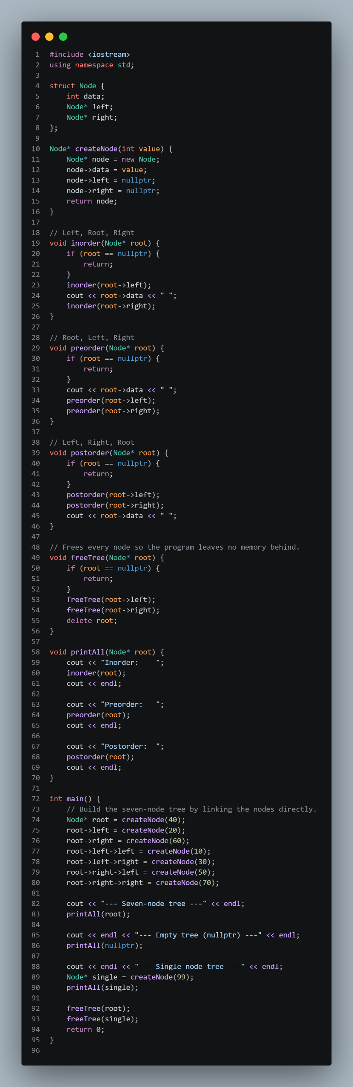
Task: 2
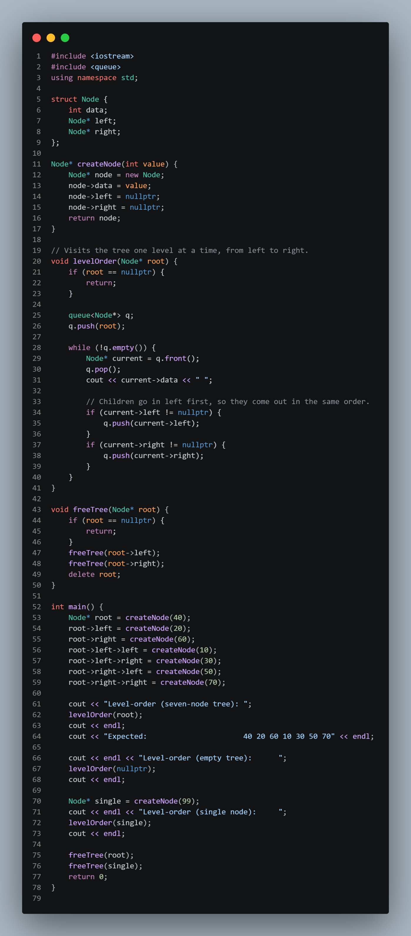
Task: 3
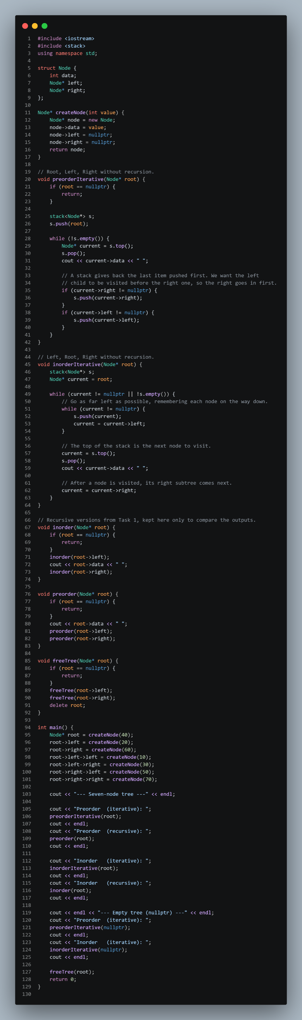
Task: 4
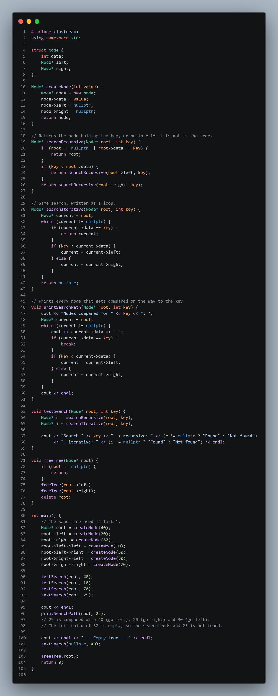
Task: 5
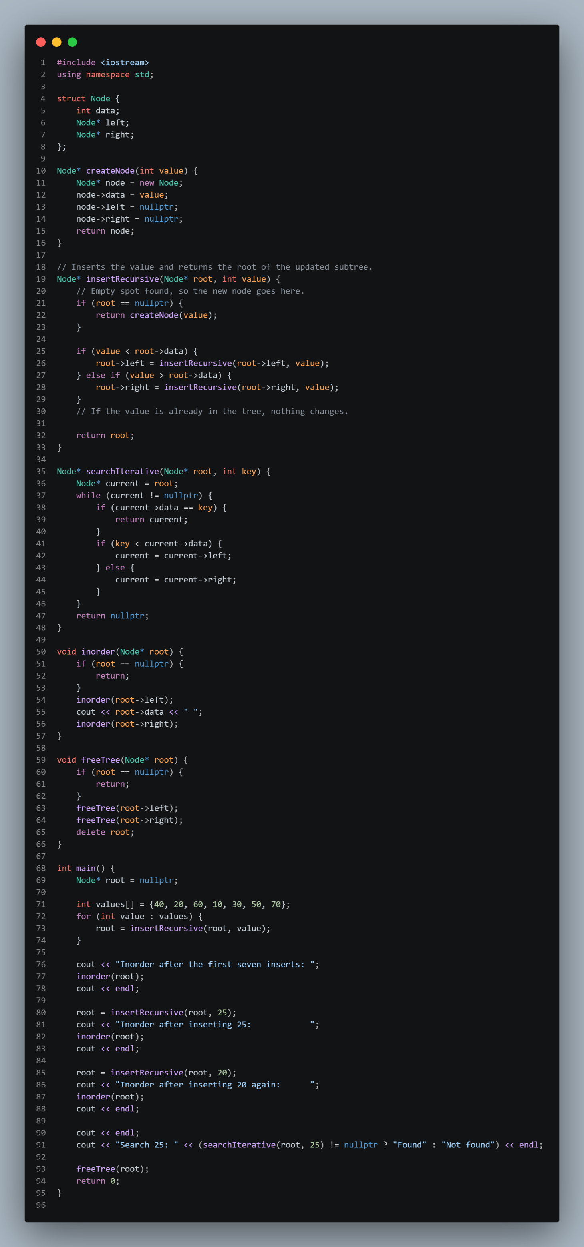
Task: 6


